
Dear colleagues! My name is NN. I will present the Russian team with the problem Coloured plastic.
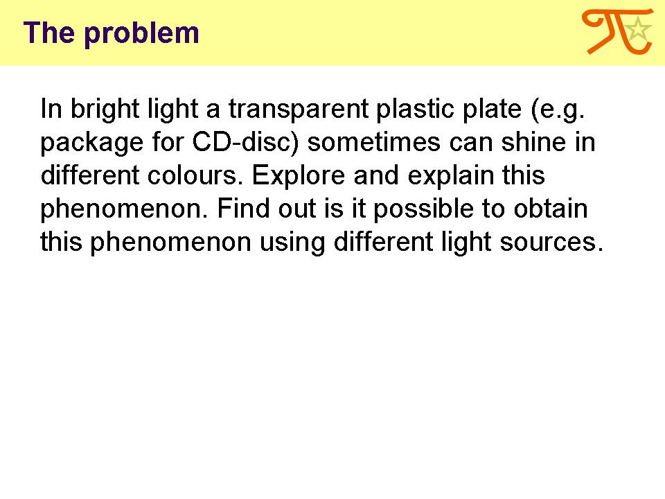
The problem says: In bright light a transparent plastic plate (e.g. package for CD-disc) sometimes can shine in different colours. We are proposed to explore and explain this phenomenon, and to find out is it possible to obtain this phenomenon using different light sources.
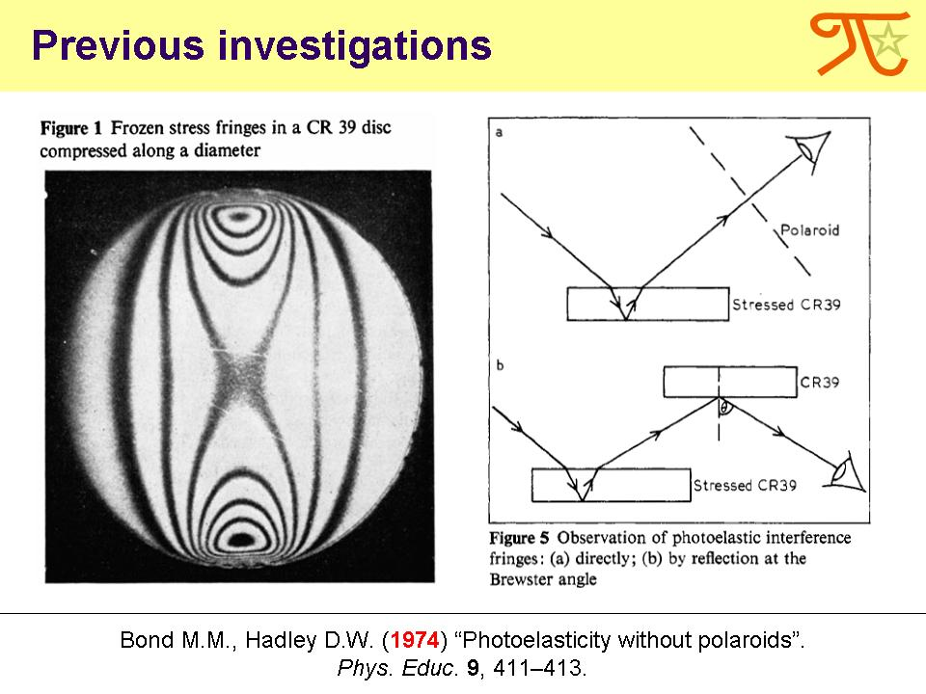
The phenomenon described in this problem is called photoelasticity. It is widely used in studies of strength of materials. A special case of photoelasticity without polaroids was previously discussed by Bond and Hadley.

Let’s begin our study with simple observations.
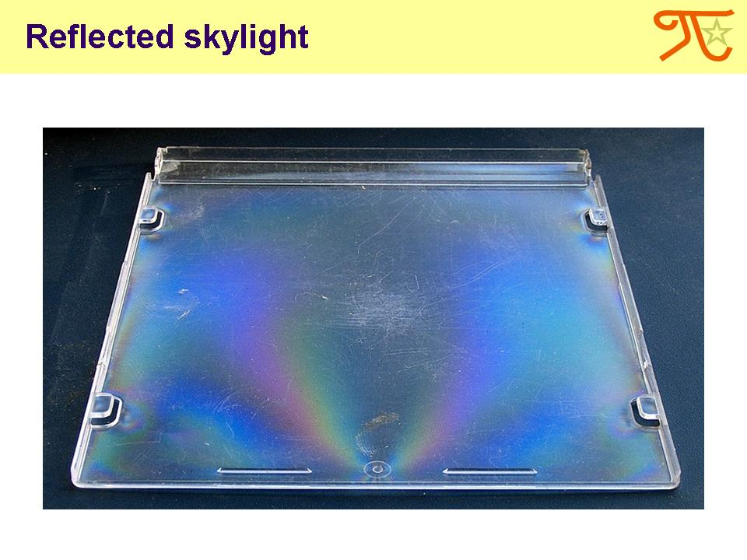
When a skylight reflects from a transparent plastic plate, in certain conditions bright colour fringes can be seen.
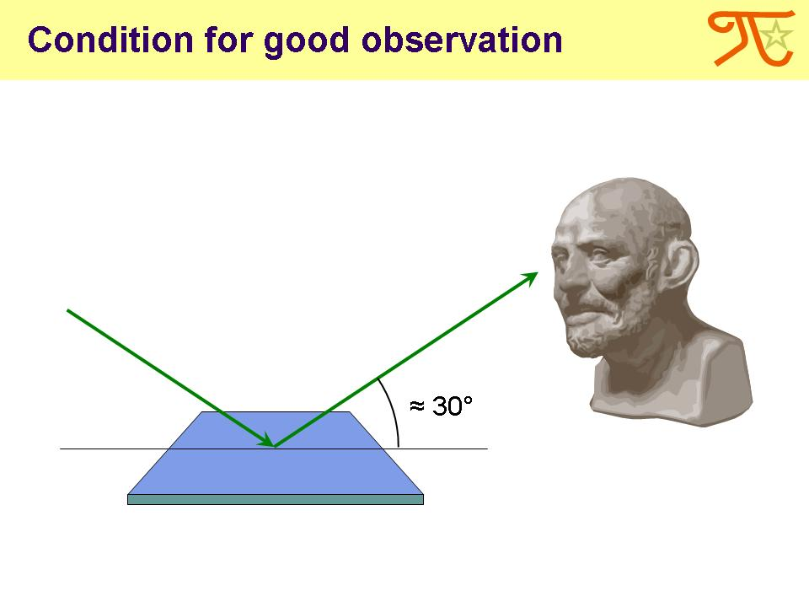
These fringes are brightest if the angle between the surface and the ray of vision is about 30°.
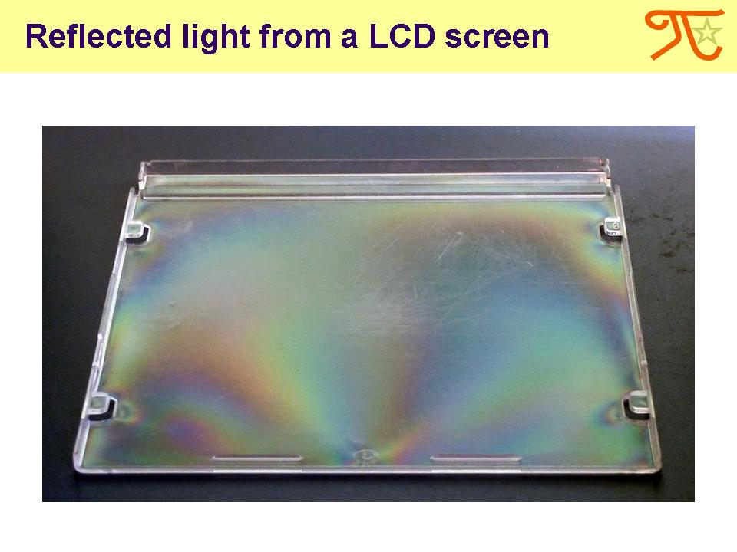
Light from a LCD screen reflecting from a plate provides a similar effect.
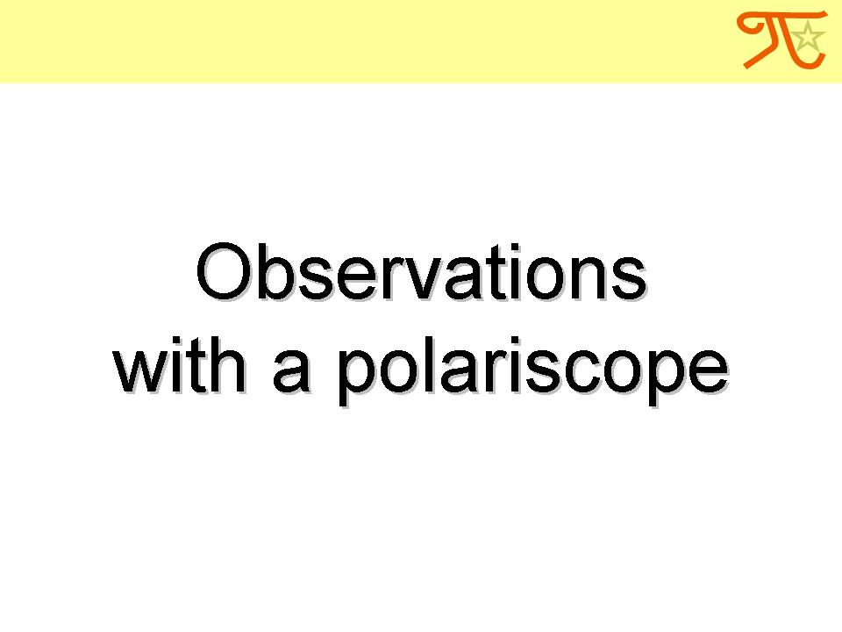
The phenomenon of coloured fringes we have observed is due to the polarization of light.
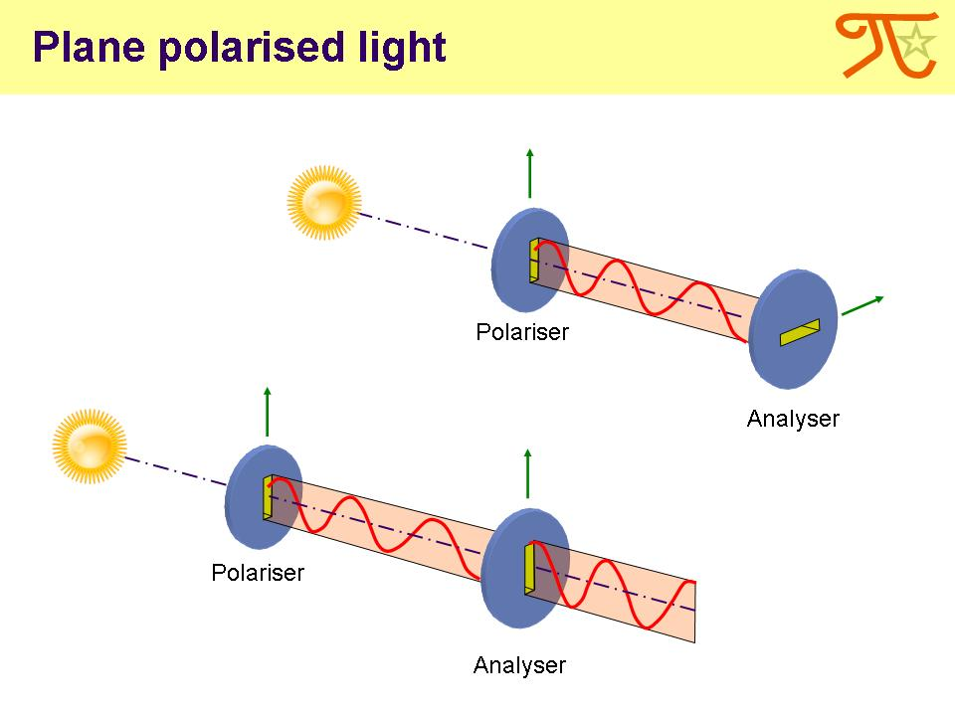
Polarization is a property of waves that can oscillate with more than one orientation. Light from most natural sources is typically unpolarized. Sending this light through the polarizer, only one its orientation is able to pass. Passing through the second polarizer (called analyzer), this light can lose its intensity depending on the rotation angle between the analyzer and the polarizer.
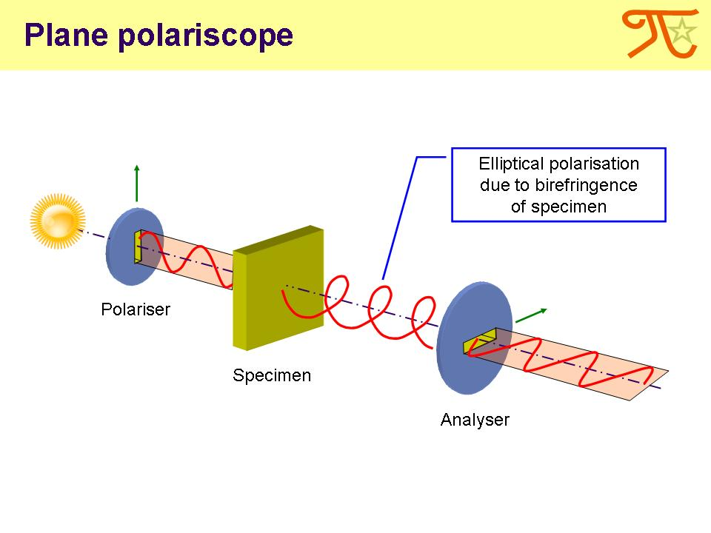
The system of two crossed polarisers is called a plane polariscope. A transparent specimen for the observation is placed between polarisers.
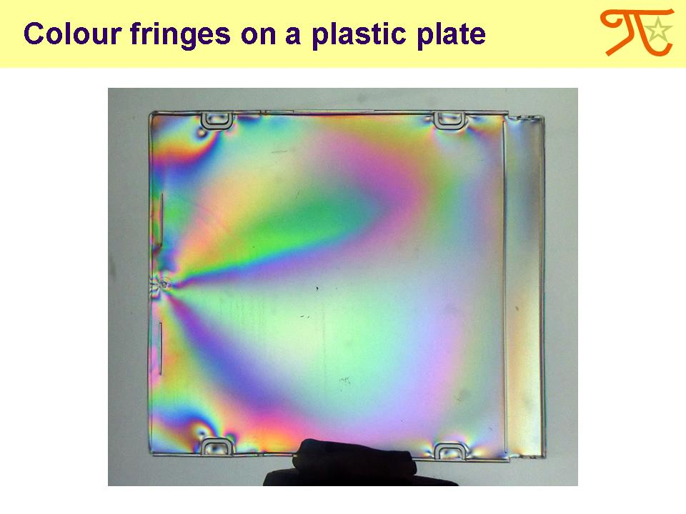
Placing our plastic plate in the polariscope, this bright pattern is observed. Note that a shape of fringes in general is the same as the pattern observed in a reflected light.

Now let me explain why and how this phenomenon occurs. First of all, I will discuss such a property of some plastics as their birefringence or optical anisotropy.
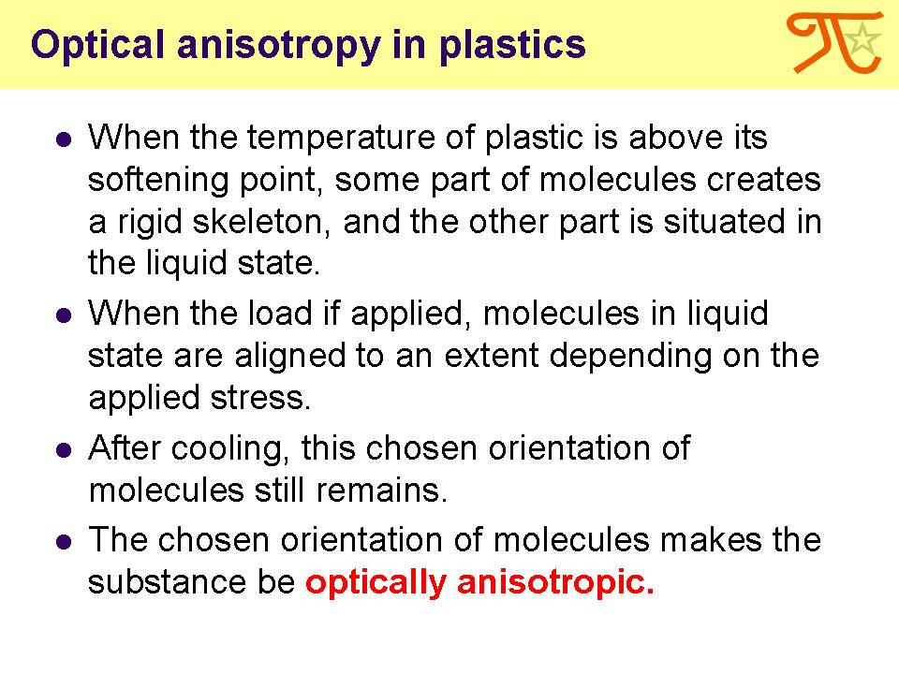
Plastic articles we used in observations usually were obtained by moulding. When the temperature of plastic is above its softening point, some part of molecules creates a rigid skeleton, and the other part is situated in the liquid state. When the load is applied, molecules in liquid state are aligned to an extent depending on the applied stress. After cooling, this chosen orientation of molecules still remains. The chosen orientation of molecules makes the substance be optically anisotropic.
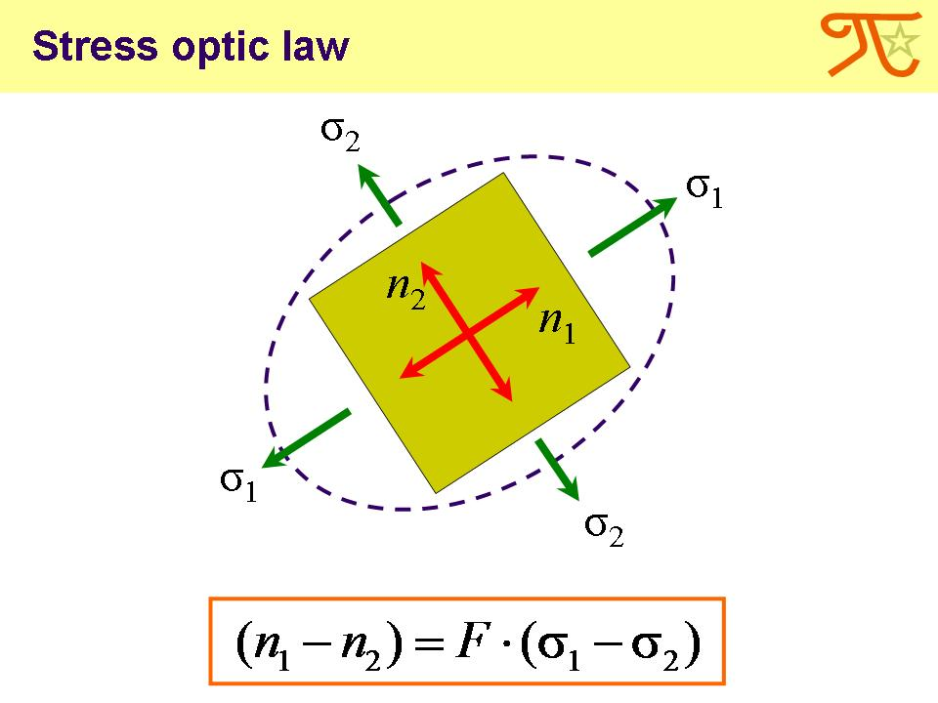
When polarised light passes through such a stressed material, it separates into two waves travelling at different velocities. Each part is oriented parallel to a direction of principal stresses (σ1, σ2), perpendicular to each other. As a result, the stressed material has two different indices of refraction (n1, n2). The stress optic law says that birefringence n1–n2 is directly proportional to the difference of principal stresses σ1–σ2.
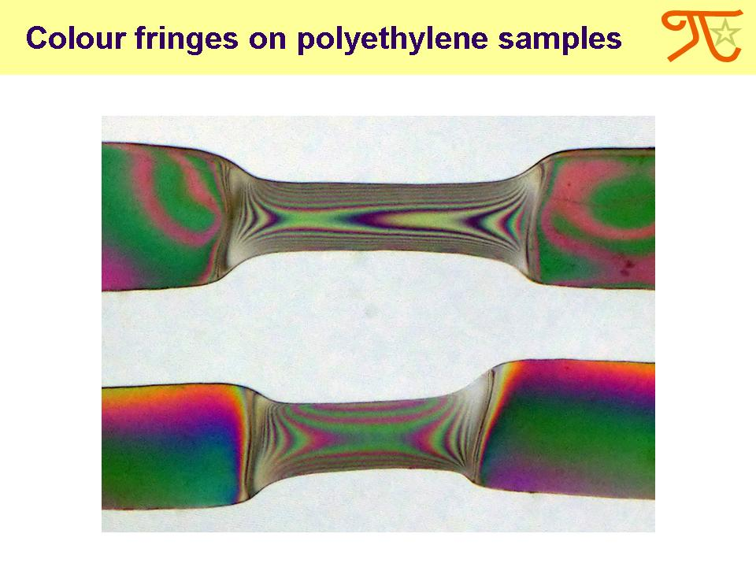
Stretching the polyethylene band over a candle frame, then cooling it and placing between the polarisers, we can observe a coloured pattern on the stretched area.
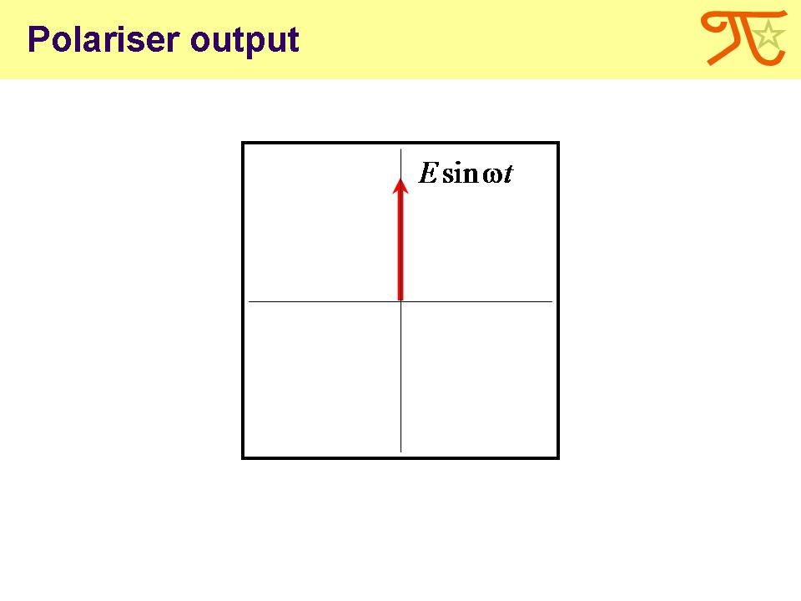
To understand the phenomenon of photoelasticity better, let’s study the principle of a plane polariscope in details.
Only the component of light with an electric vector parallel to the axis of the polarizer will be allowed to pass through the polarizer.
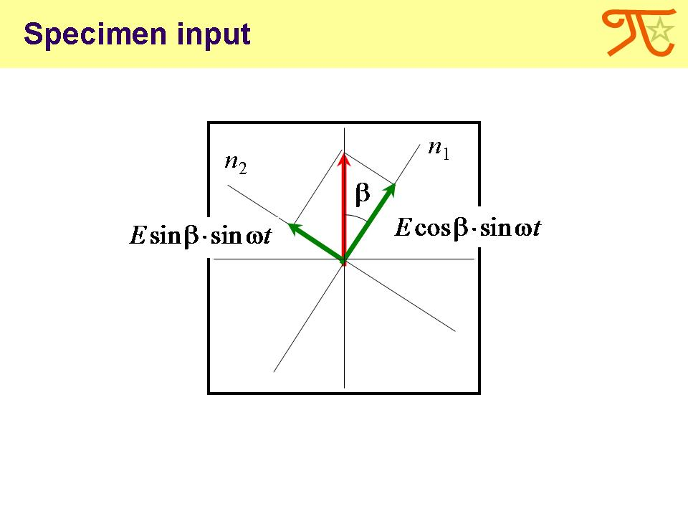
Arriving on the specimen, the wave is split into two separate waves. Each wave is oriented parallel to the direction of principal stresses.
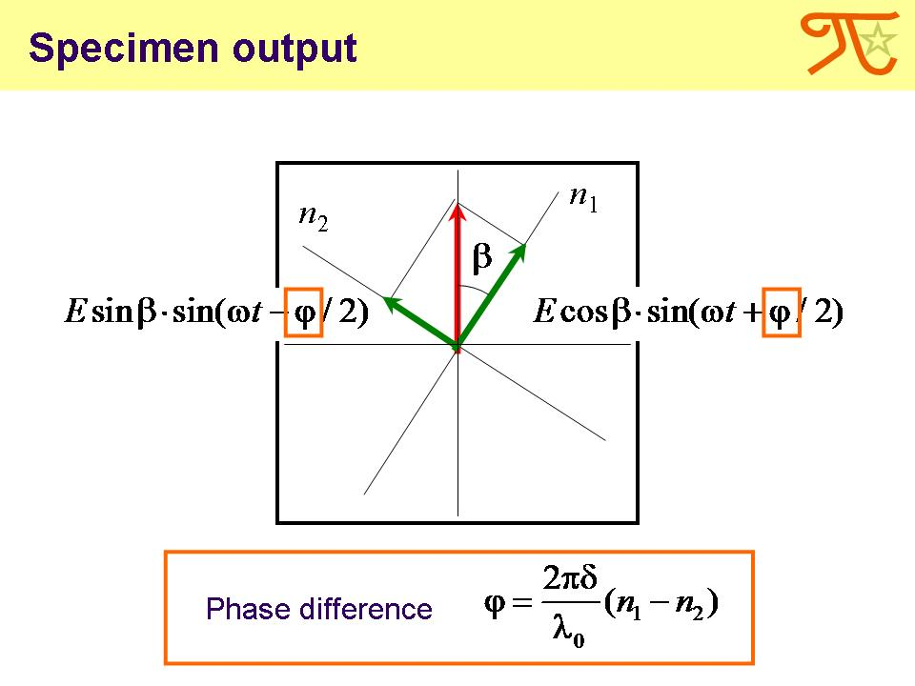
Velocities of these waves are determined by the relevant refractive indices, which are different for the two directions. Therefore, after passing through the material, the waves have the phase difference. It depends on the difference between the two refractive indices and the distance travelled by the light through the specimen.
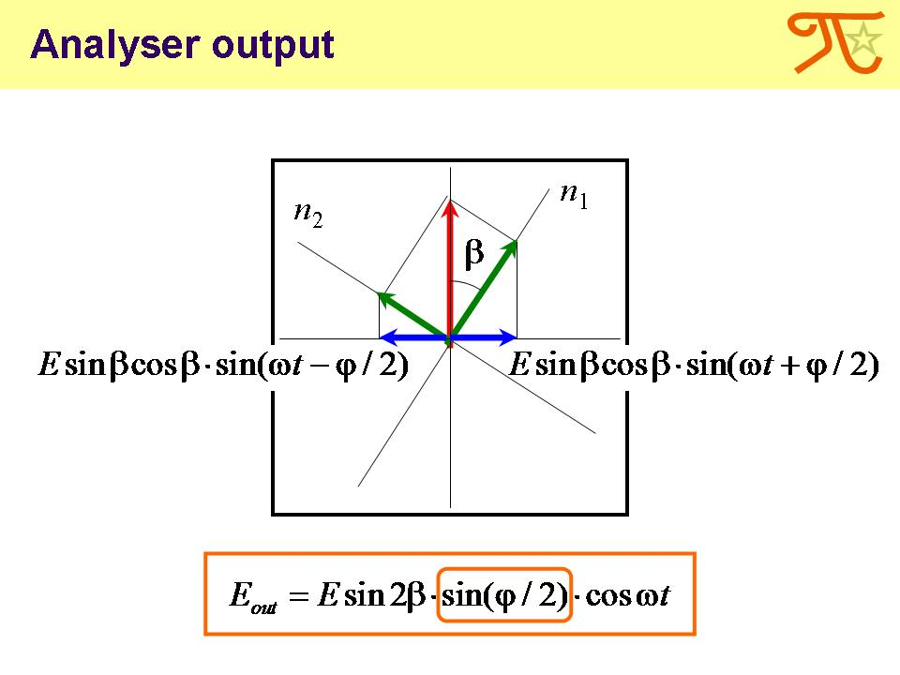
When these components are combined by the analyzing polaroid, interference effects are observed. A second polaroid is used because interference can occur only between two waves having their electric vectors parallel.
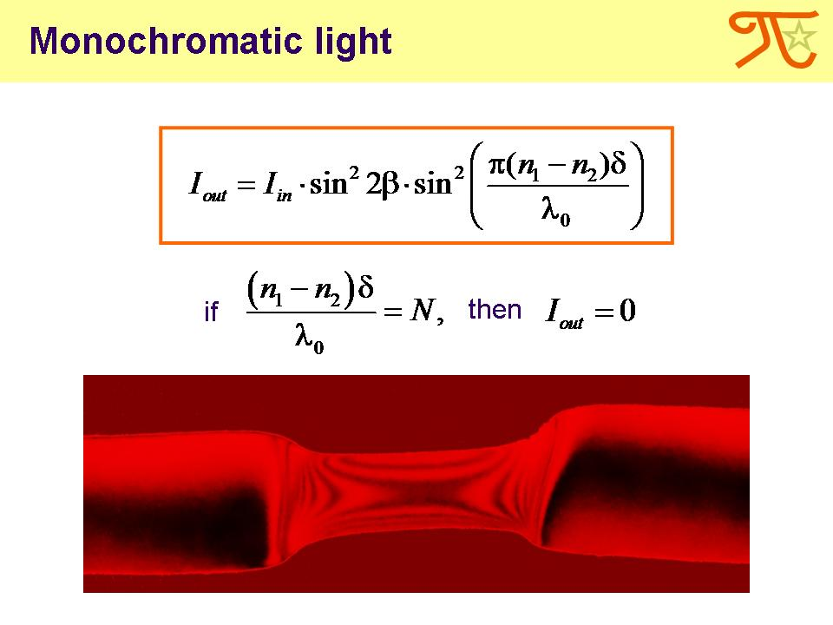
The intensity of monochromatic light on the interference pattern is proportional to the square of the amplitude. When the half-phase difference of the two compounds is integer, the intensity is zero.
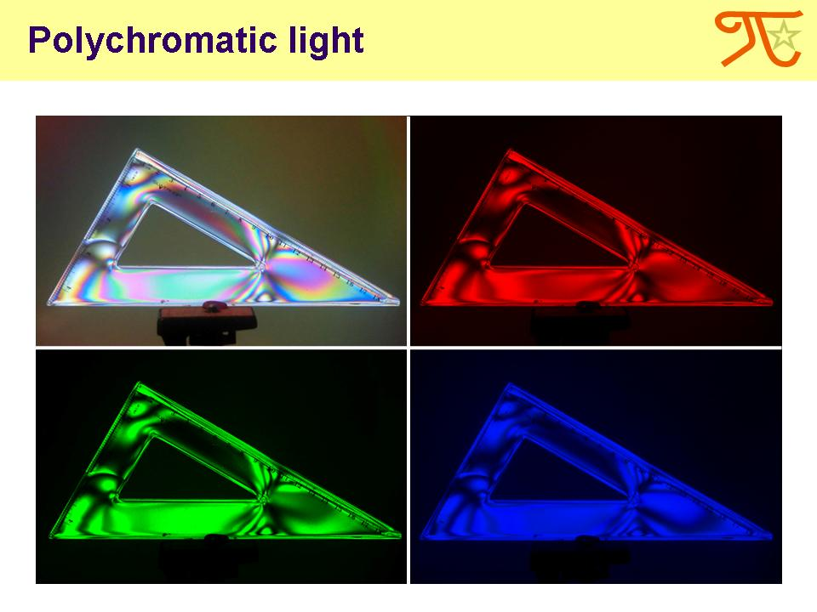
Using a computer soft, we extracted monochromatic patterns from a polychromatic one. Note that for different wavelengths there are different patterns.
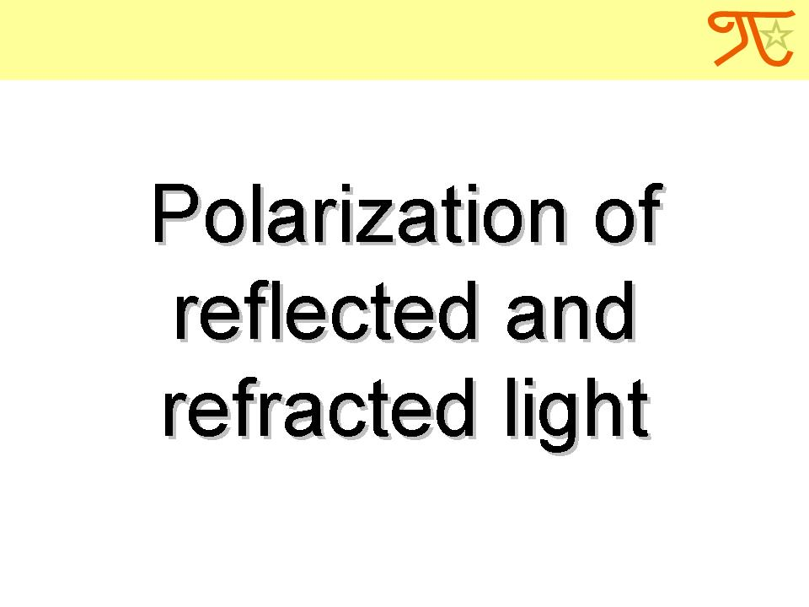
The polarization of light can also occur when it is reflected or refracted.
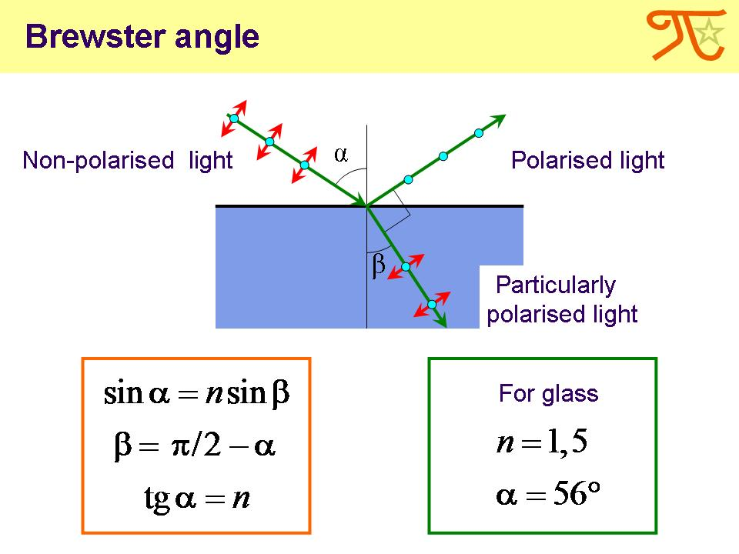
There is one certain incident angle called Brewster’s angle at which the reflected light ray is normal to the refracted one. When unpolarized light is incident at this angle, the reflected light is perfectly polarized, while the refracted light is particularly polarized. For a glass medium in air Brewster’s angle is about 56°.
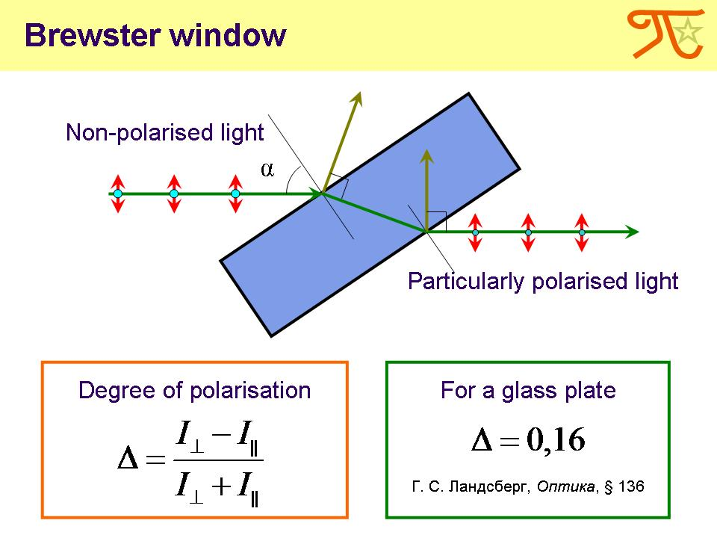
Brewster window is a glass plate tilted at Brewster’s angle. Its degree of polarization is calculated by this formula.
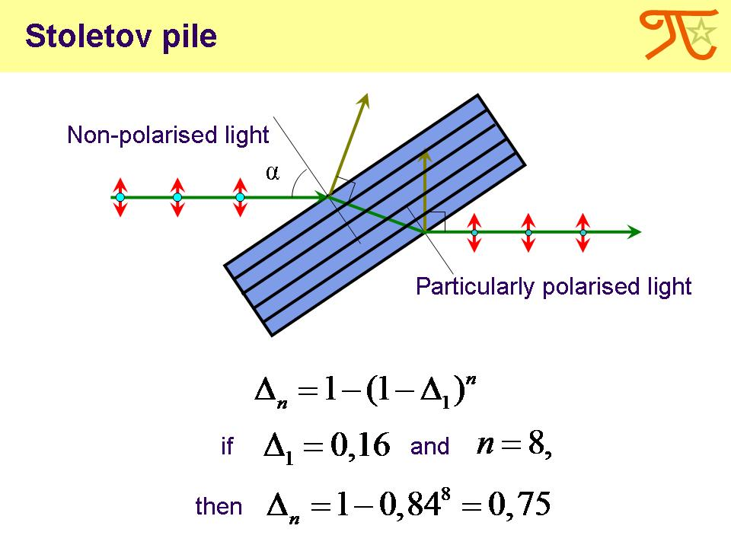
Stoletov pile is a stack of Brewster windows with a small gaps between them. This device allows to obtain a light beam with high degree of polarisation.
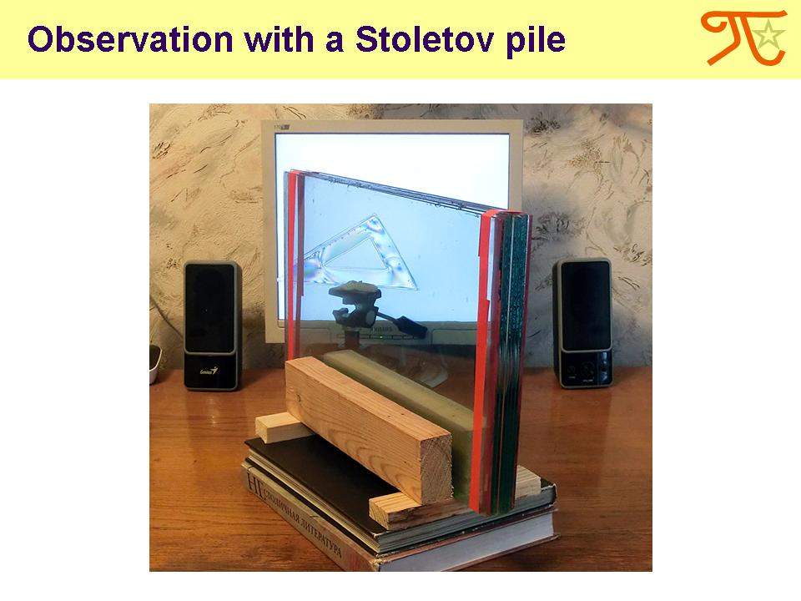
The light from LCD-screen have a high degree of polarisation. We observed the plastic ruler in this polarised light, using Stoletov pile as an analyzer.
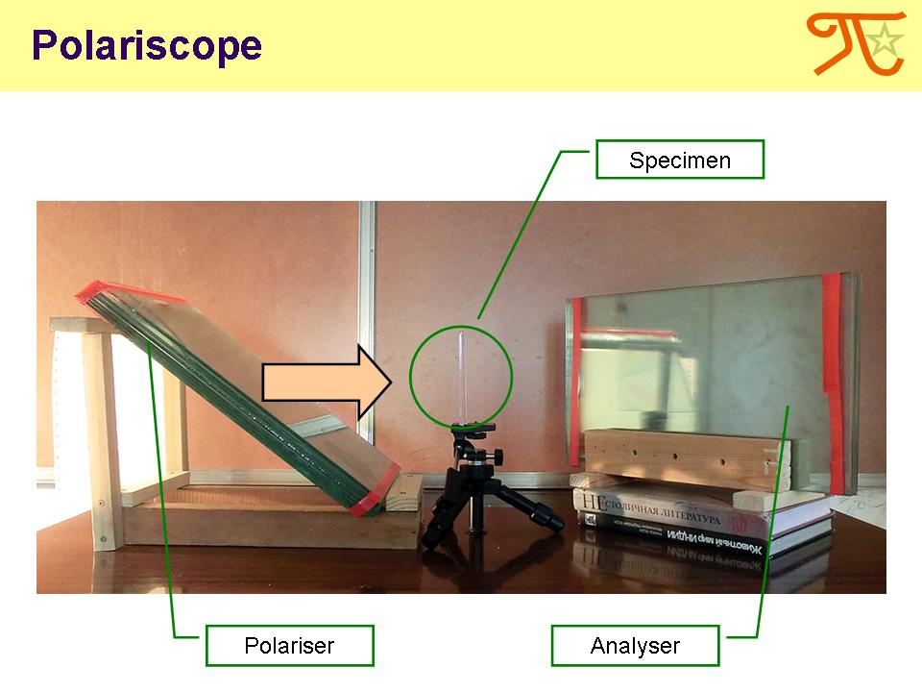
Another observation was conducted using non-polarized light and two piles as polarizer and analyzer. Every time we saw a familiar pattern.

As we explained, to observe the phenomenon of photoelasticity two polaroids are required. But can we observe coloured fringes without polaroids?
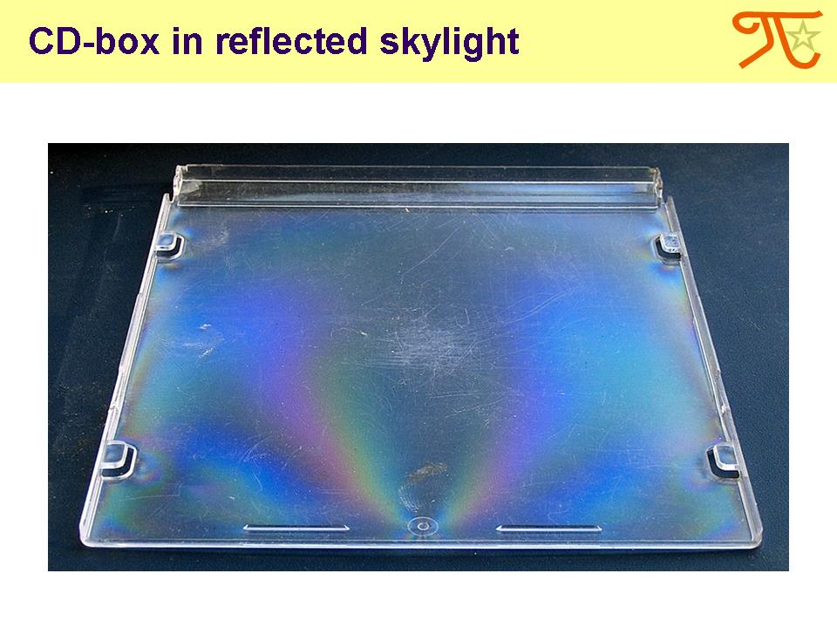
The answer is “yes”. CD-box illuminated by reflected skylight gives a similar pattern.
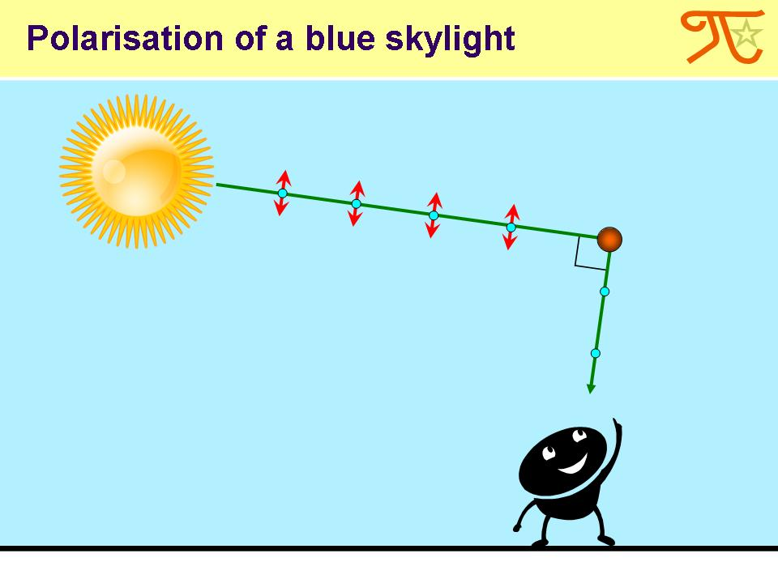
The reason is that blue skylight dissipated on the atmosphere particles becomes particularly polarized.
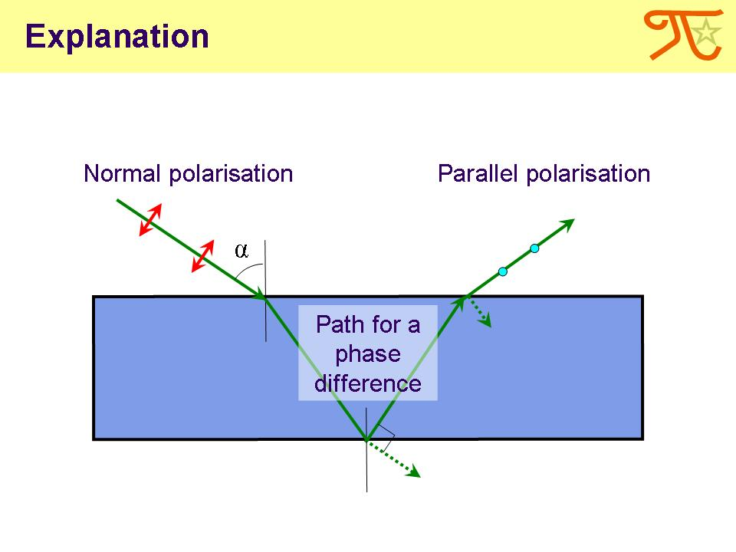
This light passes through a plate, reflects from its bottom and then exits the one more time polarizing on the surface. So the plate acts as a analyzer.
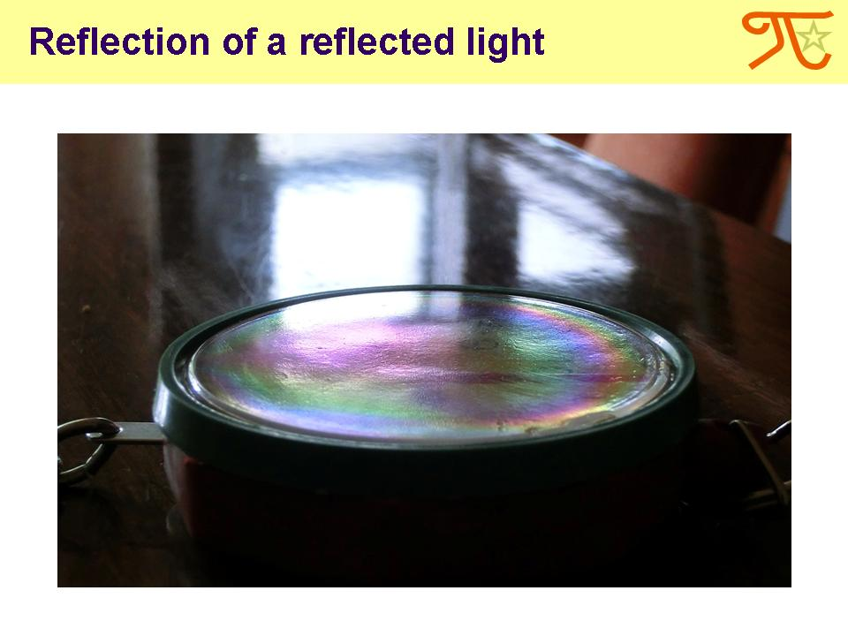
In this observation light was previously reflected from the bookcase glass. Therefore it had a high degree of polarisation.
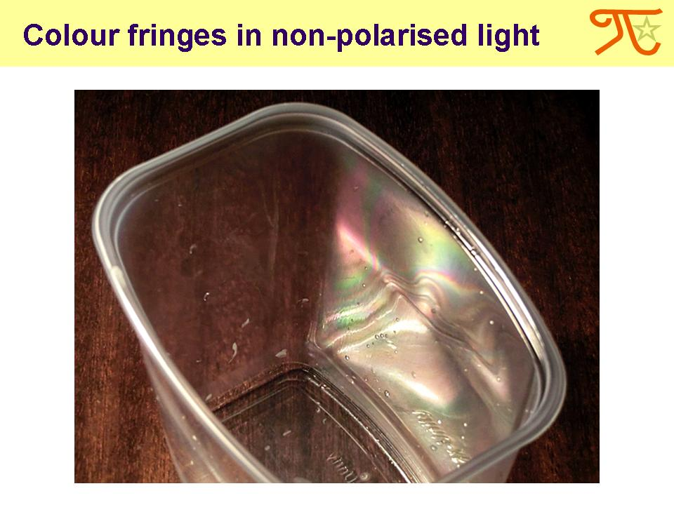
This coloured pattern of a similar origin we observed on a polyethylene package.

Let me summarize our work.
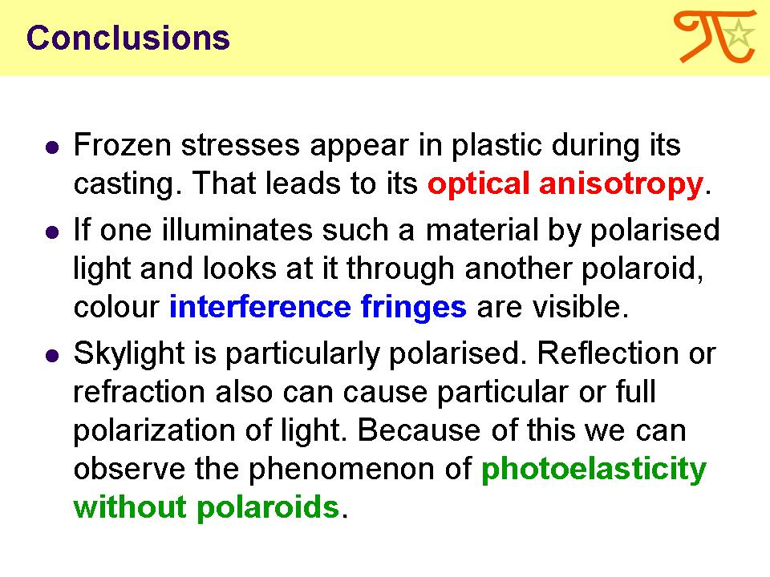
Frozen stresses appear in plastic during its casting. That leads to its optical anisotropy.
If one illuminates such a material by polarised light and looks at it through another polaroid, colour interference fringes are visible.
Skylight is particularly polarised. Reflection or refraction also can cause particular or perfect polarization of light. Because of this we can observe the phenomenon of photoelasticity without polaroids.
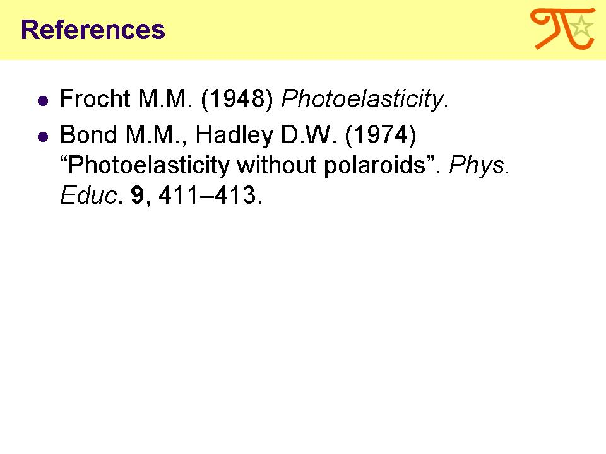
These are our references.

Thank you for your attention!

